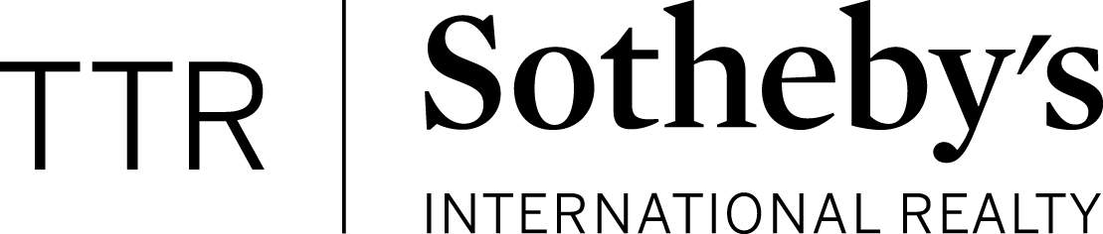

Chain of Events for Purchasers

- First Steps
  - Pre-approval by a local lender and obtain a good faith estimate to estimate your closing costs and monthly payment
  - Assess needs, wants, and wishes and x-factors

- Finding the house:
  - View properties online, visit open houses, view properties with agent, FSBOs, and water cooler chat, neighbors and friends

- Make a written offer to the seller- with agent electronically or in person

- Strategies for writing a winning offer
  - Get pre-approved by reputable local lender- makes a difference to the seller!
  - Know the area and the comps
  - Large Earnest Money Deposit (EMD about 5-10%)
  - Flexibility with settlement date and other things

- Contract Ratification (when all parties agree on all terms and price in writing)
  - Earnest money deposit is written (refunded at settlement)

- Post Ratification
  - Lender completes loan application, orders appraisal, answer lender questions ASAP!
  - Choose Title Company (if not done already at ratification)
  - Home Inspection (approximately $300-$400 for condos), Termite (approximately $70)
  - Set up insurance and utilities for your new home-prepare to move!
  - Review Closing Documents with Lender and Title Company

- Settlement at Title Company of your choosing
  - Property is paid for with your down payment and loan, EMD is refunded.
  - Closing costs approximately 2.5-3% of offer price paid at settlement. Lender will provide a good faith estimate prior to writing offer.

- Costs to buying a home outside of money brought to settlement
Earnest money deposit (have this money liquid before writing offer)
home inspection, termite inspection, appraisal, move-in fees for condos, closing costs

- Discuss Benefits of Agency and Buyer Brokerage Agreement
  - As of July 1, 2012, VA law requires a written brokerage relationship agreement before showing a property
  - Duties include:
Pointing out defects that a seller’s agent may not be able to disclose
Negotiating terms and conditions
Preparing offers and counteroffers
Maintaining confidentiality of personal and financial info
promoting buyer’s best interest
As a Realtor I am bound by the Code of Ethics

Helpful Resources for Purchasers
Property searches, Neighborhood Info, Market Statistics:
www.debranhomes.com
Safety:
https://www.neighborhoodscout.com/
http://sex-offender.vsp.virginia.gov/sor/
http://dcimpact.org/
Schools:
http://www.greatschools.org/

